Word – Tutorial 3
CBTL121 26Feb2014
Data File needed for this tutorial is Class.docx
In conjunction with a local community college, Robin Kinsella has organized a series of computer training classes for Parkside residents to be held in the Parkside community center. She has begun work on a report for the board that outlines basic information about the classes and introduces the instructors. It’s your job to format the report, add a table at the end containing a preliminary schedule, and create a sample graphic that Robin could use in a handout advertising the classes. When you are finished, Robin will expand each section of the report, adding more text to each. (Note: Text you need to type is shown in bold for ease of reference only; do not bold the text unless otherwise instructed.) Complete the following:
- Create a new folder in your H-drive and name it Word – Tutorial 3.
- Open the file Class located on the website: www.cbtl121.yolasite.com under the MS WORD tab and then save it as Class Report in the Word – Tutorial 3 folder.
- Display the rulers and nonprinting characters and make sure the document is displayed in Print Layout view.
- Format the document headings with the Heading 2 Quick Style. Use the Intense Quote style for the “Summary” heading and then indent the summary paragraph to match.
- Click to the left of the heading “Schedule,” insert a page break, move the insertion point to the end of the document, and then create the table shown in Figure 3-41.
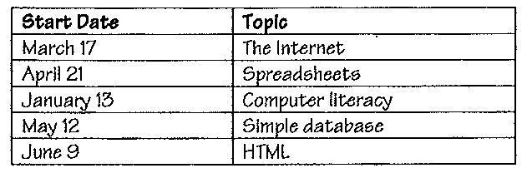
Figure 3-41

- Sort the table by the contents of the Start Date column in ascending order.
- In the appropriate location, insert a new row for a word-processing class that starts on February 10.
- Delete the HTML row at the bottom of the table.
- Modify the widths of both columns to accommodate the widest entry in each.
- Format the table with banded rows of pink and white and dark red shading (go to Table Styles ribbon) for the header row, and then save your work.
- On page 1, replace the text “[instructor names]” with the following list of instructors and their specialties. Insert a tab after each name, remembering that the list of specialties won’t align properly until you complete Step 11. Remember to use the Shift+Enter key combination (instead of just the Enter key) to insert a new line for each name without adding extra space:
Felicity J. Connelly-Porter Word processing
Antonio Morales Multimedia software
Jon Davis Web design
Amelia Cuntz Database design and SQL programming

- Select the list of instructors and their specialties, and then insert a left tab stop 2.5 inches from the left margin.
- Below the heading “Equipment Needs,” locate the first sentence of the second paragraph, which begins “There are currently five…” At the end of that sentence, insert a footnote that reads: The computers should run either Windows Vista or Windows XP.
- Insert a Next Page section break after the table, format the new page 3 in landscape orientation, and then insert a SmartArt graphic that illustrates the advantages of computer classes. Use the Continuous Block Process graphic from the Process category and, from left to right, include the following text: Computer Education, Technological Advantage, and New Career Prospects. Size the SmartArt graphic to fill the page.
- Create a footer for sections 1 and 2 that aligns your name at the left margin. Insert the page number, without any design elements and without the word “Page,” below your name.
- Create a header for just section 1 using the Alphabet header style, enter Parkside Computer Classes as the document title, close Header and Footer view, and then save your work.
- Insert a cover page using the Stacks style, verify that the document title is automatically inserted in the cover page, enter An Informational Report for the subtitle, and then enter your name for the author.
- Save the report and submit the finished documents to your instructor in electronic form (via email) to 2014cbtl121@gmail.com. The Subject for your email should be: Student number: Word – Tutorial 3. Here is an example: 20142015687: Word – Tutorial 3.

