Word – Tutorial 2
CBTL121 25Feb2014
Data Files needed for this Tutorial is: Getting.docx, Staff.docx
Natalie asks you to work on a document that explains how to get started working with
the designers at Pemberly Furniture and Interiors. The document starts by introducing the
entire Pemberly design staff and then lists the steps involved in a major home renovation. Natalie also asks you to create a document listing the names of the firm’s interior designers and interior decorators.

- Open the file Getting located on the website www.cbtl121.yolasite.com under the MS WORD tab.
- Create a New Folder in your H Drive and name it Word – Tutorial 2.
- Save the document as Getting Started in your Word – Tutorial 2 folder.
- Use the Spelling and Grammar checker to correct any errors in the document. Assume that all names in the document and the term “Feng Shui” are spelled correctly.
- Proofread the document carefully to check for any additional errors. Look for and correct errors in the last two paragraphs of the document that were not reported when you used the Spelling and Grammar checker.
- Change the left and top margins to 1 .5 inches using the Page Setup dialog box. Make sure to apply the change to the whole document.
- In the list on the second page of the document, select the paragraph that begins “Interview potential construction…” and move it so that it follows the paragraph that reads “Review the final design plan.”
- Format the heading and subheading in the suggested heading font for the Office theme. Change the font size to 16 point.
- Make all edits and formatting changes shown in Figure 2-36, and then save your work.

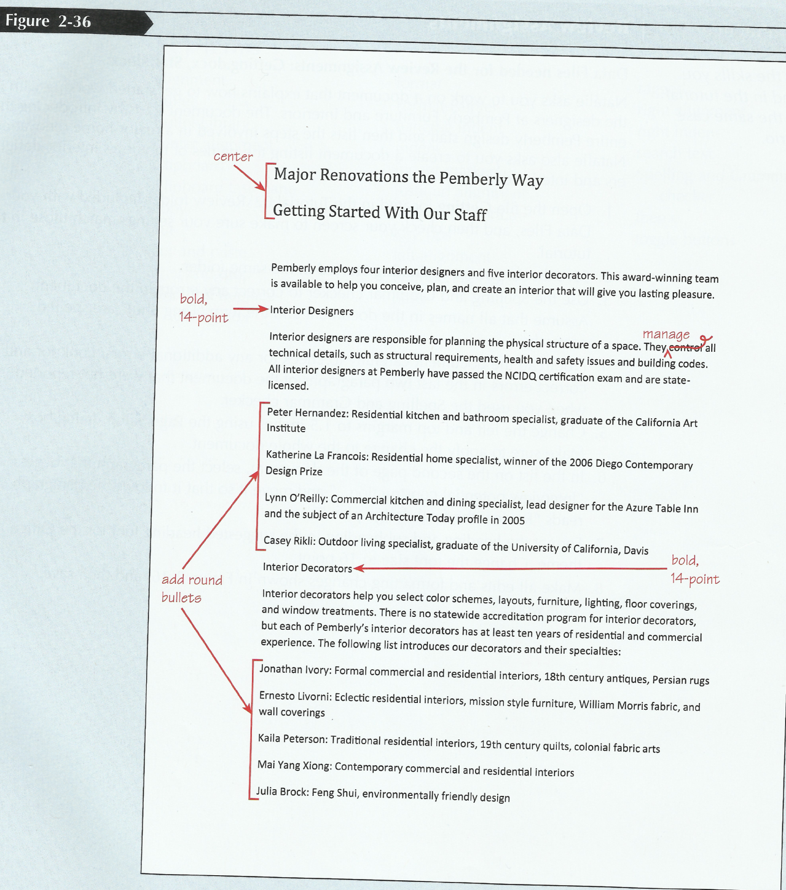
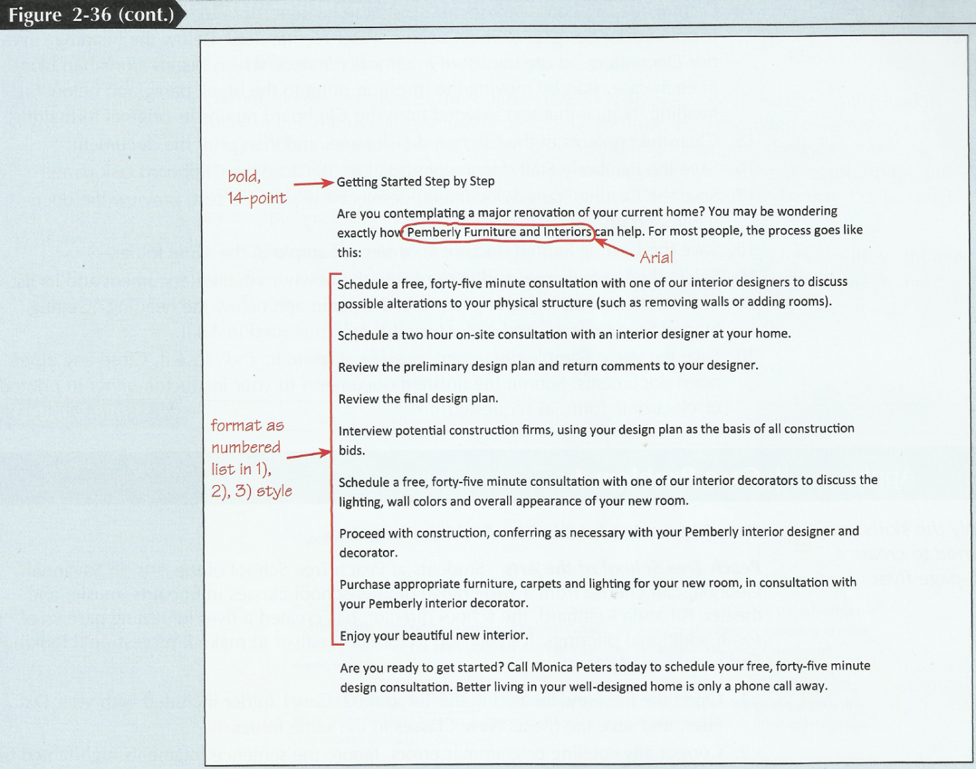
- In the last paragraph of the document, replace “Monica Peters” with your first and last name.
- Below the heading “Interior Designers,” justify the paragraph that begins “interior designers are responsible for....” Click the Increase Indent button once. Note that Word indents the justified paragraph slightly to match the bulleted list below it. Click the Increase Indent button again to indent the paragraph a full 0.5 inch. Similarly, justify and indent the paragraph below the heading “Interior Decorators” and the paragraph below the heading “Getting Started Step by Step.” Finally, justify and indent the last paragraph in the document, and then indent the two bulleted lists and the numbered list to match the other indented paragraphs. When you are finished, the text and lists below the three boldface headings should all be indented by 0.5 inch. Save the document.
- If necessary, move the heading “Getting Started Step by Step” to the top of page 2.
- Display the Clipboard task pane. Copy the list of interior designers and their specialties (starting with Peter Hernandez and ending with Casey Rikli) to the Clipboard. Also copy the list of interior decorators and their specialties (beginning with Jonathan Ivory and ending with Julia Brock) to the Clipboard.
- Open the file Staff located on the cbtl121 website and save the document as Pemberly Staff in Word – Tutorial 2 folder on your H Drive. In the subtitle, insert your first and last name after the word “by.”
- Display the Clipboard task pane. Below the heading “Interior Designers,” paste the list of interior designers, which begins “Peter Hernandez.” Below the heading “Interior Decorators,” paste the list of interior decorators, which begins “Jonathan Ivory.” In each case, start by moving the insertion point to the blank paragraph below the heading. Notice that text inserted from the Clipboard retains its original formatting.
- Clear the contents of the Clipboard task pane
- Save the Pemberly Staff document and close it. Close the Clipboard task pane.
- Save the Getting Started document, deselect any selected text.
- Save the Getting Started document as Verve Sample in the same Word – Tutorial 2 folder.
- Select the Verve theme (in the Page Layout Tab), and then review the newly formatted document and its list of fonts. Check the company name in the paragraph below the heading “Getting Started Step by Step” and make sure it is still formatted in Arial.
- Save the Verve Sample document and close it. Close any other open documents. Submit the finished documents to your instructor in electronic form (via email) to 2014cbtl121@gmail.com. The Subject for your email should be: Student number: Word – Tutorial 2.
Here is an example: 20142015687: Word – Tutorial 2.

