Word – Tutorial 1

There are no Data Files needed for this Tutorial.
Andrew asks you to write a letter to a local author, Philippa Gallatin, inviting her to an upcoming convention. He also asks you to create an envelope for the letter. You’ll create the letter and envelope by completing the following steps. (Note: Text you need to type is shown in bold for ease of reference only; do not bold the text unless otherwise instructed.)
- Open a new blank document.
- Compare your screen to the checklist in Figure 1-12, and change any settings if necessary. In particular, make sure that nonprinting characters are displayed.
Window Element | Setting
Nonprinting Characters | Displayed
Rulers | Displayed
Word Window | Maximized
Zoom | Page Width
Font | Identical to setting shown in figures
Font Size | Identical to setting shown in figures
Figure 1-12: Word Window Checklist
- Press the Enter key four times to insert enough space for the company letterhead.
- Type the date November 25, 2010 using AutoComplete for “November.”
- Press the Enter key twice, then type the following inside address, using the default paragraph spacing for now:
Philippa Gallatin
787 First Street
Albany, NY 12205

- Press the Enter key twice, then type the letter’s salutation, body, complimentary closing, and signature line, as shown in Figure 1-34 below. Accept any relevant AutoCorrect suggestions. Use the default line and paragraph spacing; do not insert any extra blank paragraphs.
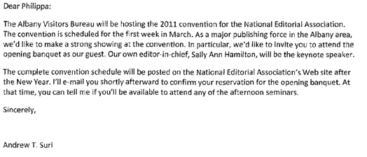
Figure 1-34
- Save your work as Gallatin Letter on your Desktop.
- Practice using the keyboard to move the insertion point around the document. Use the arrow keys so the insertion point is positioned immediately to the right of the “a” in “Philippa” in the inside address.
- Press the spacebar and then type M., so the first Line of the inside address reads “Philippa M. Gallatin.” (Don’t forget the period after the middle initial.)
- Undo the change and then redo it.
- Scroll to the beginning of the document and proofread your work.
- Correct any misspelled words marked by wavy red lines. If the correct spelling of a word does not appear in the shortcut menu, close the list, and then make the correction yourself. Remove any red wavy lines below words that are spelled correctly.
- Click at the end of Andrew’s name in the signature line, press the Enter key twice, and type your initials in lowercase.
- Select the inside address and remove the extra paragraph spacing from the selected paragraphs.
- Select the entire document and change the line spacing to single spacing.
- Save your changes to the letter, and email the document to 2014cbtl121@gmail.com.
SKILL DEVELOPMENT:
- Add an envelope to the document. Use your own address as the delivery address. Do not include a return address.
- Save your changes and close the document.

