How to create a GMAIL email account
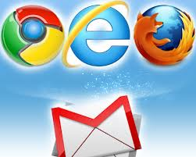

Click on this link: https://accounts.google.com/SignUp

Or

Open the Gmail website. Click the blue “CREATE AN ACCOUNT” button in the top-right corner. This will take you to the “Create a new Google Account” page. Creating a Gmail account creates an entire Google account that you can use to access other Google products and services.

2.
Come up with a username. Your username will become your new Gmail email address. Have a backup or two handy in case your desired name is already taken. If your username is not available, you will be given several related options, or you can try a different one.

3.
Fill out the rest of the required information. You will need to enter your first and last name, your birthday (for age verification), your gender, your phone number in case you lose access to your account, and a verification email address. You also need to enter which country you reside in. The mobile phone number is recommended but not required. Google can send you a text in case you lose access to your Gmail account.

4.
Complete the CAPTCHA. This is a verification tool that ensures that a real person is creating the account. If you can’t read it, click the refresh button next to the text field to get a new one, or click the speaker button to have it read out loud through your computer speakers. After you fill out the CAPTCHA, select your current location. Choose your country of residence, even if you’re planning on using the email elsewhere.

5.
Agree to the privacy policy. Take the time to read the entire privacy policy so that you are aware of what Google can and can’t do with your personal information. Check the box if you agree to Google’s terms.
6.
Click Next Step. This will take you to your Google+ profile creation page. All Google accounts create a Google+ account when they are created. You can choose whether or not you would like to add a picture to your account. Choose whether or not you want your +1 information shared. This option will tailor the Google +1 icons you see across the web. If you keep the box checked, you will be able to see the sites that your friends +1. This service is used to tailor ads to you.

