Powerpoint – Tutorial 2
CBTL121 Hand in on 06March2014
Data Files needed for this tutorial is: AKRibbon.jpg, LandTour.pptx,Naturalist.jpg
In addition to the presentation on general information about Alaskan Cruises and Land Tours, Chad wants presentations on information about the specific cruises and land tours that his company operates. He asks you to create a PowerPoint presentation on one of the Alaskan land tours. Do the following:

- Create a new folder in your H-drive and name it Powerpoint – Tutorial 2.
- Open the file LandTour, , located on the website: www.cbtl121.yolasite.com or http://comlaw-online.unizulu.ac.za/ and then save the file as Denali Tours in the Powerpoint – Tutorial 2 folder.
- Apply the Module theme.
- Replace “Chad Morley” in the subtitle in Slide 1 with your name.
- Add the footer “Denali Land Tours” and slide numbering to all the slides except Slide 1.
- Switch to Slide Master view, and then, in the Title Slide Layout, insert the picture file AKRibbon. Position the graphic along the bottom of the slide. It will cover up the footer and page number placeholders, which is no problem because those items don’t appear on the title slide. Close Slide Master view when you are finished.
- In Slide 2, change the layout so you can place clip art to the right of the bulleted list, and then insert a clip-art image of a yellow bus (by searching for bus in the Clip Art task pane). Close the Clip Art task pane.
- Increase the size of the clip art so it’s approximately double its original width, and then move the clip art so its top is aligned with the top of the first bulleted item.
- Recolor the clip art to Accent colour 2 Dark (in the Dark Variations section of the Recolor menu).
- In Slide 3, change the layout so you can place a picture on the right, insert the picture file Naturalist and then apply the picture style Reflected Rounded Rectangle.
- Increase the size of the Naturalist picture until the picture height is about the same height as the entire bulleted list.
- In Slide 4, convert the bulleted list to the Continuous Block Process SmartArt graphic.
- In Slide 5, insert a table of the appropriate size and add the text as follows:

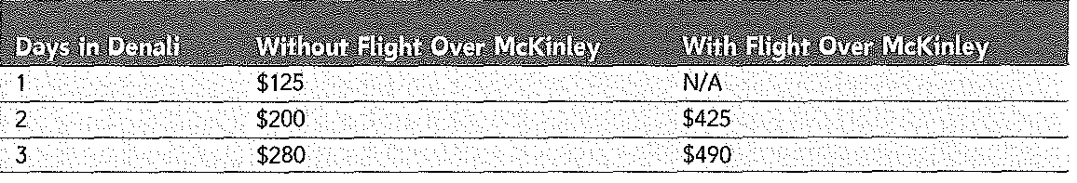
- Center-align the text and numbers in column 1, and then right-align the text and numbers in columns 2 and 3.
- Reduce the width of column A until it is so narrow that “Days in” is on one line and “Denali” is on a second line in cell A1.
- Reduce the column widths of columns B and C until “Over McKinley” in each of the cells 31 and Cl is on a second line of text. (Hint: You might have to make several adjustments to the border lines to get the column widths as you want them.)
- Position the (now much smaller) table in the center of the white background on the slide. You don’t need to center it exactly.
- Make sure Header Row and Banded Rows are checked in the Table Style Options group of the Design tab, and then change the table style to Dark Style 1 — Accent 1.
- In Slide 6, use a right tab stop to align the dollar amounts along the right edge of the slide.
- Change the layout of Slide 7 to Title Only, draw a Regular Pentagon (hold down the Shift key while drawing so that all five corners stay the same angle), and then position the pentagon in the middle of the white area of the slide.
- Flip the pentagon so a flat edge is on top and a corner is pointing down.
- Insert a text box on each side of the pentagon, starting with the top of the pentagon and going clockwise around it, with the phrases “Exciting tours,” “Low prices,” “Expert guides,” “Full amenities,” and “Flexible schedules.”
- Rotate and reposition these text boxes so they are flush with their respective sides of the pentagon. Press the Alt key if you need to override the snap-to-grid feature.
- To Slide 8 only, apply the design theme titled “Trek.”
- Check the spelling in the presentation, view the slide show, fix any problems you see, and then save your changes.
- Submit the finished file to your instructor in electronic form (via email) to 2014cbtl121@gmail.com. The Subject for your email should be: Student number: PowerPoint – Tutorial 2. Here is an example: 20142015687: PowerPoint – Tutorial 2.

